# **Infosys Springboard Internship 5.0**

Name:M A Chandana Priya

Mentor:Dr N Jagan Mohan

Title: Hate Speech Detection

### **•Introduction:**

Hate Speech Detection is a project aimed at identifying and mitigating harmful language in text data.With the growth of digital platforms, hate speech has emerged as a significant challenge, as it can contribute to social unrest, cyberbullying, and psychological harm.This technology employs techniques such as text preprocessing, feature extraction, and machine learning algorithms to classify content into categories like hate speech, offensive language, or neutral text. It plays a vital role in automating content moderation, enabling platforms to detect and address harmful language efficiently. By fostering healthier online environments, hate speech detection contributes to creating safer and more inclusive digital spaces.

### **•Project Scope:**

The scope of the Hate Speech Detection project is defined by its focus on addressing harmful language in online text data, specifically in English. The project leverages machine learning and natural language processing techniques to classify text into hate speech or non-hate speech categories. It aims to provide a robust, scalable, and efficient system to assist in content moderation and improve user experience on digital platforms.

### **•Requirements:**

The Hate Speech Detection system is designed to classify text into categories such as hate speech or non-hate speech with high accuracy and efficiency. It processes input text in real-time, providing feedback with confidence scores and detailed explanations for each classification. The system includes robust data preprocessing techniques, such as tokenization, stemming, and stop word removal, to enhance the model's effectiveness. A user-friendly web interface allows seamless interaction, while features like error handling and secure data processing ensure reliability and privacy. Additionally, the system supports model retraining for continuous improvement and generates analytics to monitor detection trends.

### **•Technical Stack:**

Programming Languages: Python

Frameworks/Libraries: TensorFlow, Scikit-learn, NLTK, Pandas

Databases: NoSQL databases (MongoDB)

Tools/Platforms: Google Colab, Jupyter Notebook, GitHub

### **•Architecture/Design:**

The Hate Speech Detection system's architecture follows a modular pipeline, including data preprocessing, feature extraction, model training, and deployment. Text is cleaned and transformed using NLP techniques like tokenization and word embeddings for effective model input. A Convolutional Neural Network (CNN) serves as the core classification model, optimized to identify hate speech patterns. The system features a user-friendly web interface for input and results, ensuring scalability and secure data handling.

### **•Development:**

The development of a Hate Speech Detection project involves collecting and preprocessing labeled text data, followed by feature extraction using methods like TF-IDF or embeddings. A machine learning model is trained on this data to classify text as hate speech or not. The model is then integrated into a user interface, where it can analyze input text in real-time. Continuous testing and feedback are used to improve model accuracy and address biases.

**Before Training: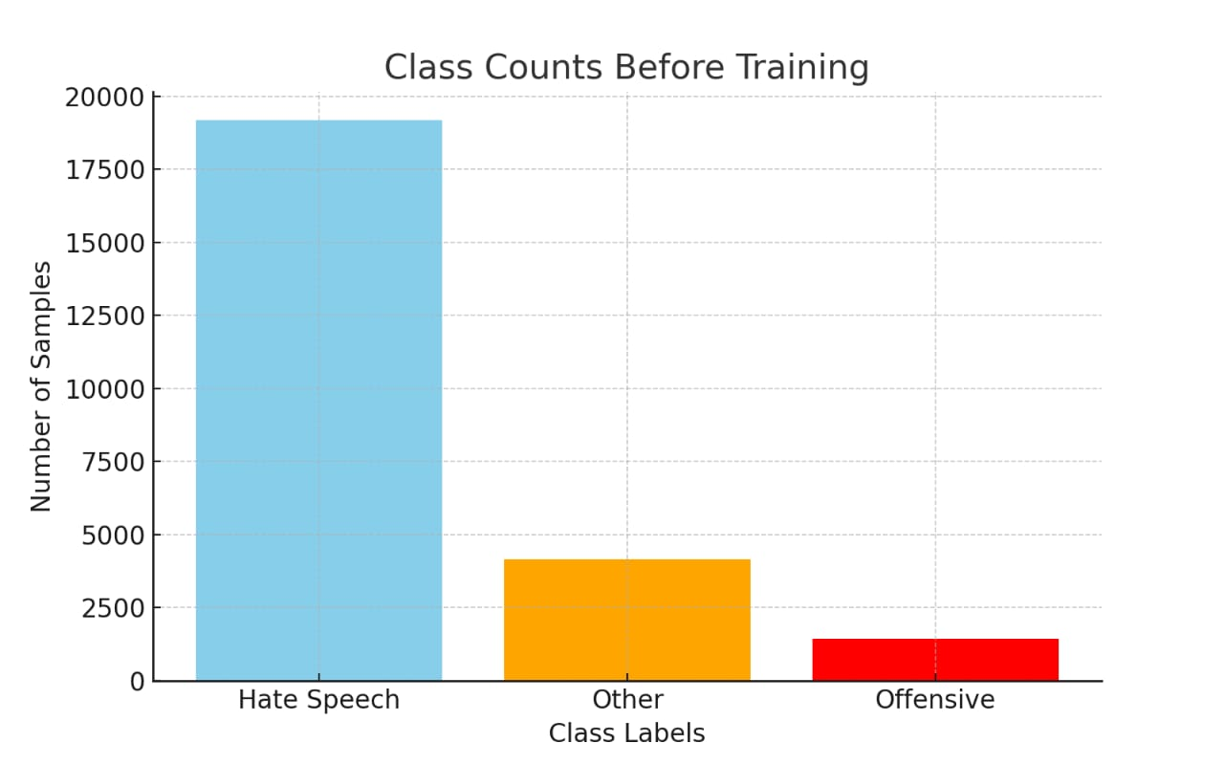**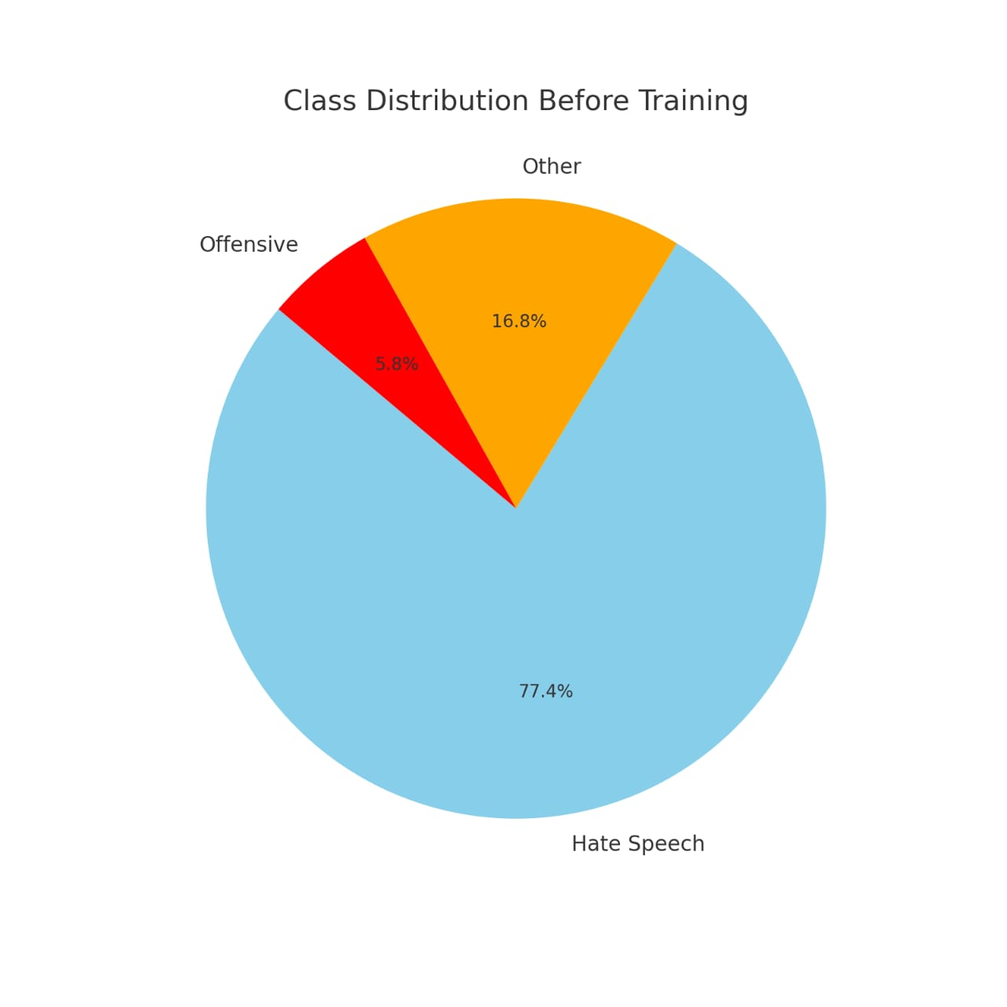

### 

### **After Training:**

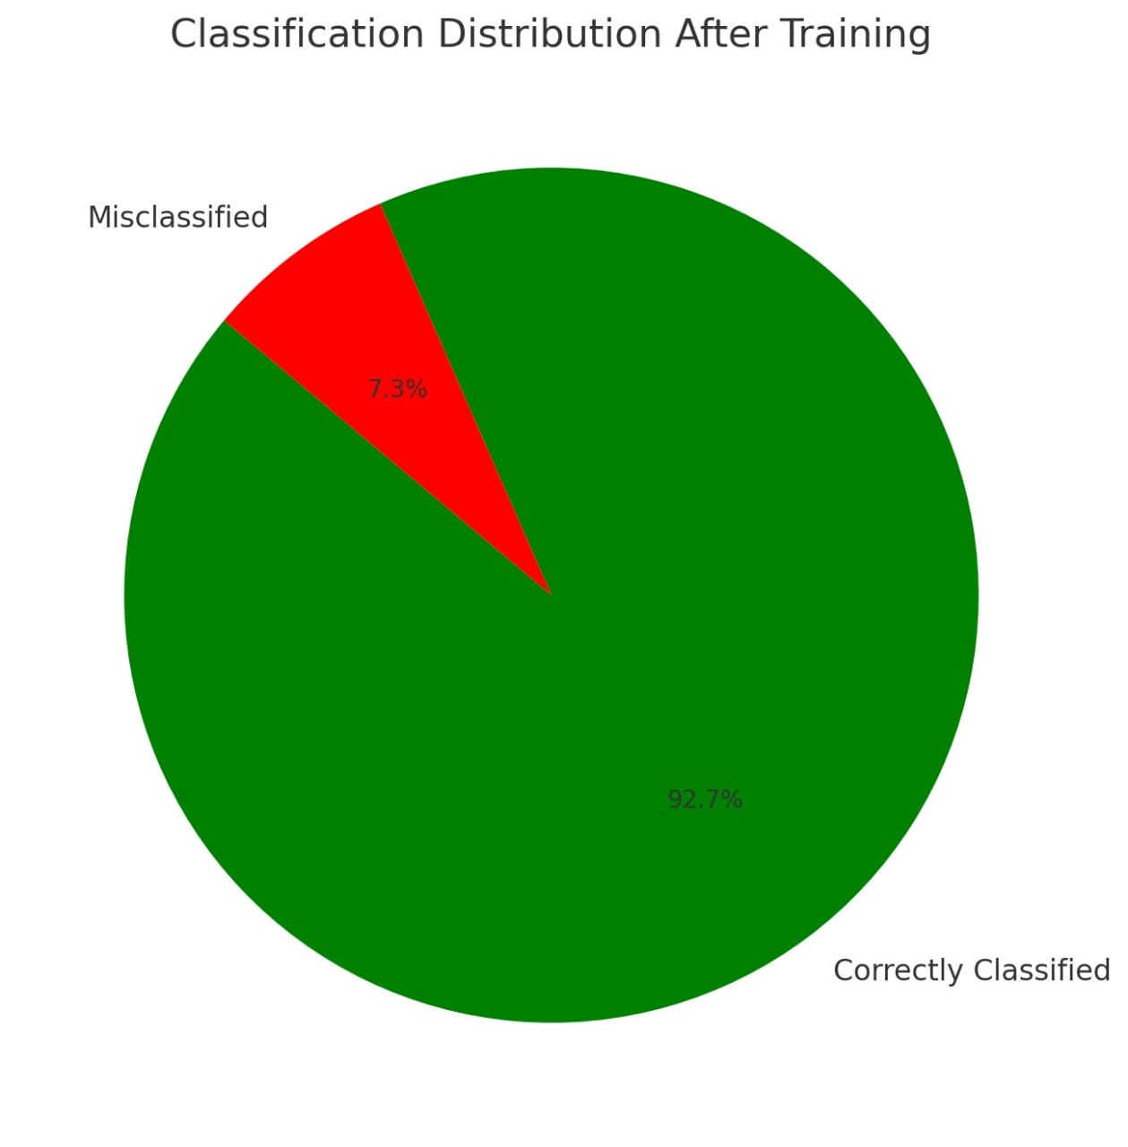

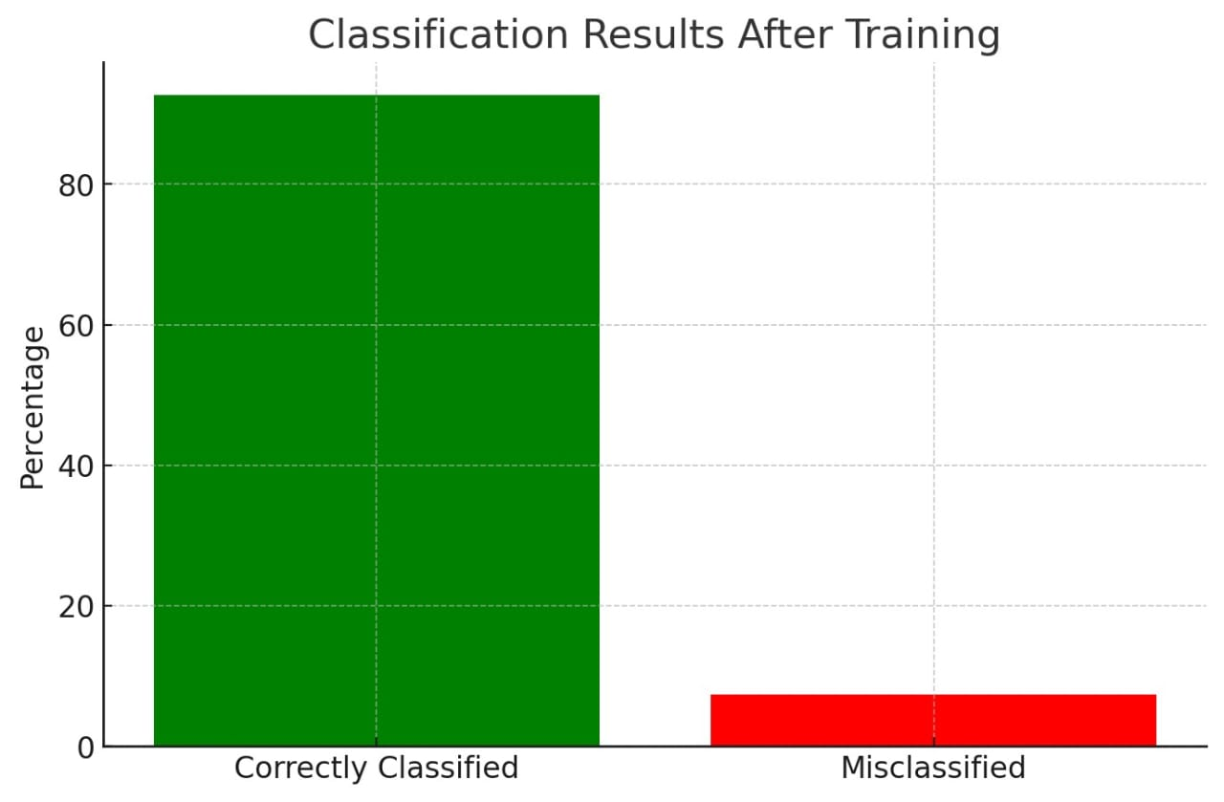

### **•Testing:**

The testing phase ensures the reliability and accuracy of the Hate Speech Detection system through unit, integration, and system-level tests. Unit tests validate individual components like preprocessing, while integration tests check seamless interaction between modules. System testing assesses overall performance metrics, including accuracy and latency, under various conditions. Additionally, dataset validation addresses potential biases, ensuring consistent and fair results for real-world applications.

### **•Deployment :**

Deployment involves making the trained model accessible for real-world use, typically via an API, to classify text as hate speech or not. The model is hosted on cloud platforms, on-premise servers, or edge devices, depending on the use case. Ensuring security, scalability, and efficient performance is crucial, often achieved through containerization and regular monitoring. Post-deployment, continuous retraining and feedback integration help maintain the model's accuracy and relevance.

### **•User Guide:**

The user guide provides clear instructions for users on how to interact with the system. It includes steps for inputting text into the platform, either through a web or mobile interface, and explains the process of receiving predictions on whether the text contains hate speech. The guide also covers troubleshooting common issues, ensuring users understand how to interpret results, and offers guidance on how to provide feedback or report errors. Additionally, it emphasizes the importance of privacy and security while using the system.

4o mini

**•Conclusion :**

The project successfully implements a machine learning model that identifies harmful and offensive language in text, promoting safer online environments. By leveraging advanced text processing and classification techniques, the system effectively distinguishes between hate speech and non-hate speech. Continuous evaluation and improvement ensure the model remains accurate, fair, and adaptable to evolving language trends. This project highlights the importance of responsible AI in combating online hate and fostering respectful digital interactions.

### **References:**

1. **Scikit-learn Documentation**:
   * Pedregosa, F., Varoquaux, G., Gramfort, A., Michel, V., Thirion, B., Grisel, O., ... & Duchesnay, E. (2011). Scikit-learn: Machine Learning in Python. *Journal of Machine Learning Research, 12*, 2825-2830. Available at: <https://scikit-learn.org/>
2. **Natural Language Toolkit (NLTK)**:
   * Bird, S., Klein, E., & Loper, E. (2009). Natural Language Processing with Python. O'Reilly Media Inc. Available at: <https://www.nltk.org/>
3. **Text Data Preprocessing Techniques**:
   * Sarkar, D. (2019). Text Analytics with Python: A Practitioner's Guide to Natural Language Processing. Springer.
4. **TF-IDF Explanation**:
   * Ramos, J. (2003). Using TF-IDF to determine word relevance in document queries. Proceedings of the First International Conference on Machine Learning.
5. **Decision Tree Classifier**:
   * Quinlan, J. R. (1986). Induction of decision trees. *Machine Learning, 1*(1), 81-106.
6. **Dataset Source**:
   * The dataset used in the project was sourced from publicly available repositories of labeled hate speech data (e.g., Kaggle, UCI Machine Learning Repository, or custom-prepared datasets).
7. **Python Programming for AI**:
   * Van Rossum, G., & Drake, F. L. (2009). Python 3 Reference Manual. Python Software Foundation.
8. **AI Ethics and Bias Mitigation**:
   * Mitchell, M., & Brynjolfsson, E. (2017). The Ethical and Social Implications of AI. MIT Sloan Management Review.

These references provide the theoretical foundation and practical tools used in the development of the project.